**Mobile tower Architecture**

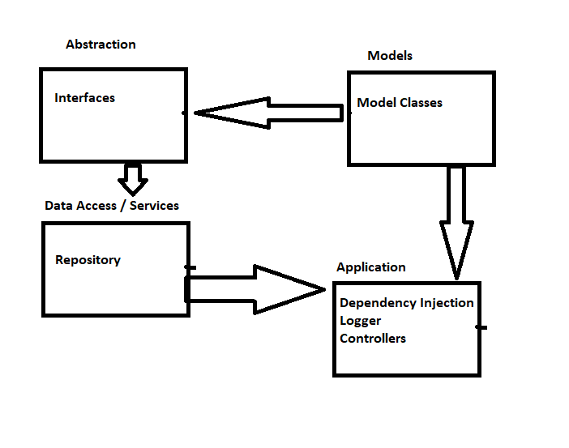

**1) Authenticate Technicians**

**Token Identity Service:-**

Service will generate/Refresh tokens

1. User will enter the credentials
2. Identity API will receive username and password
3. API will validate the credentials
4. If Valid user then user details along with roles will added into claim set
5. Claim will be wrapped into token along with token expiry
6. Generate token(Like JWT Token)

Token will be verified in a web API or web App

**Web App :-** Token will be stored in form cookies and verified from cookies

**Web API :-**  Token will be added into HTTP request header (Authentication bearer Token as API Key) and verify token from request header

MVC authorization filter will be used to verify token

**2) A technician should be able to close, register , reassign a maintenance request.**

User management API will be use to register user , lock user and assigning roles to user

**3) Technician should be able to send / receive/ alerts and notifications**

**Email notification :-** SendGrid will be use to send email notification also we can use sendgrid template management functionality to use maintain different templates

**SMS notification :-** Twilio will be use to send SMS notification also we can define custom template table to store SMS templates.

**Push notification :-** For Mobile push notification we can use firebase push notification service

**4) There should be a complete log track of the MR. The live updates should flow from technician to the corporate office.**

For Tracking purpose, we can use database tables (Trigger functionality of SQL Server)

We can maintain audit tables for any user record changes from audit we can show the history record to corporate office.

For Instrumentation purpose we can use Nlog framework

**5) Reporting :-** We can use SSRS reporting service

**6) Should be able to handle high volume of data and transactions**

1. To handle high volume data performance we need to maintain noncluster index in SQL database

2. Also we can create partitioning of tables to store large data